**Question 1.**

**Question 1(A).**

**Question 1(B).**

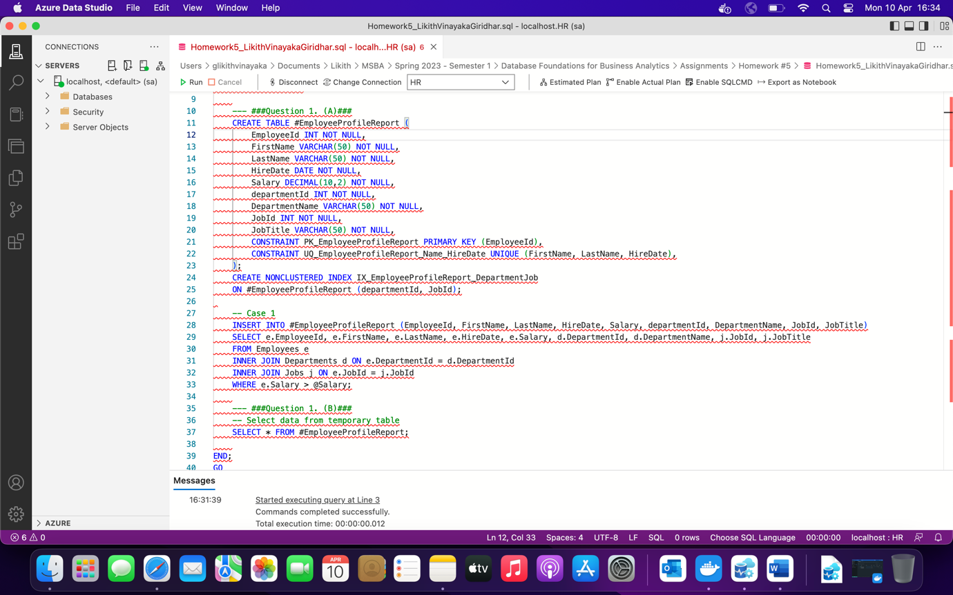

**Question 1 (C).**

**Case (i):**

**Case (ii):**

**Case (iii):**

**Question 2.**

**Question 2(A).**

**Question 2(B): (a), (b), (c)**

**Question 2(C):**

**Question 2(D):**

**Case (i):**

**Case (ii):**

**Case (iii):**

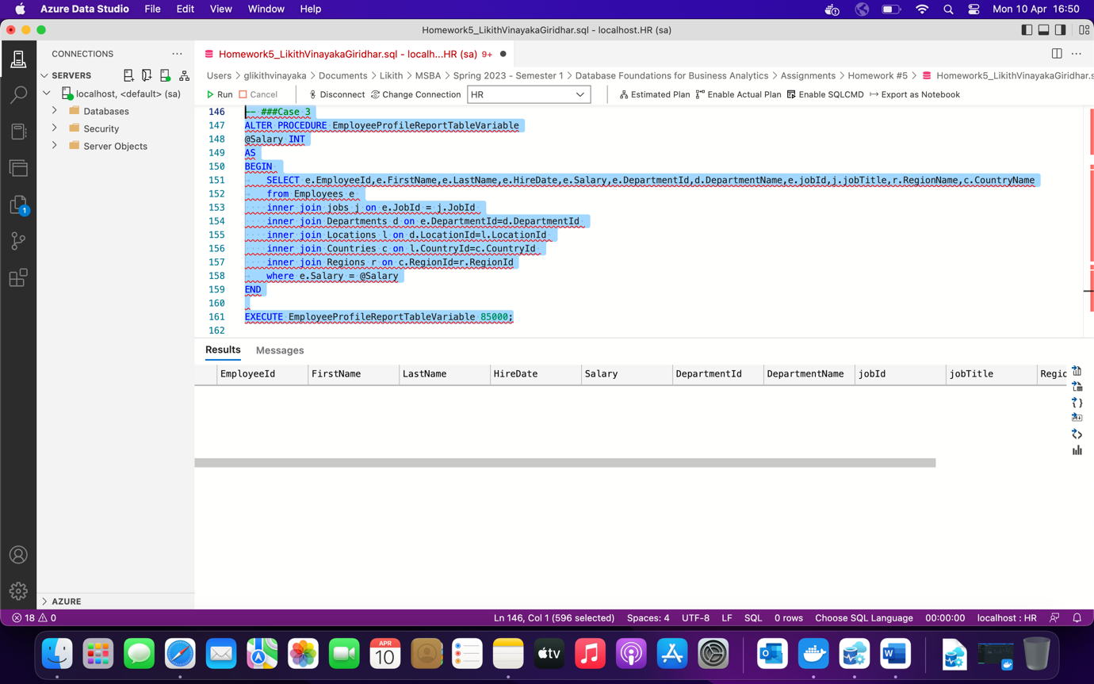

**Question.3**

1. When we are having a complex join operation then it is Not good to use temporary tables.

**Ans. (b) False**

1. The local temporary table is automatically dropped when the SQL connection is closed.

**Ans. (a) True**

1. One obvious scenario for which local temp table is useful when you have a process that needs to store intermediate results.

**Ans. (a) True**

1. Which statement will select all columns from global temporary table temp1:

**Ans. (a) Select * from ##temp1**

1. Which of these statements is correct?

**Ans. (b) Multiple users across multiple connections can have Global temporary tables with the same name.**

1. Which statements is not correct?

**Ans. (a) We can create Primary key on temp tables**

1. What will be the output of the two SELECT statement below?

SELECT DAY('2022-10-19')

SELECT DAY('10/19/2022')

**Ans. (b) Both will return 19**

1. What is the correct value of SELECT ROUND(128.647, 2,1)

**Ans. (a) 128.640**

1. What is the output of SELECT CHARINDEX('am','I am an amazing SQL SERVER EXPERTS',5)

**Ans. (c) 9**

1. Which is the correct statement to execute stored procedure EmployeeSalarySELPerJobIdDeptId which has two input parameters JobId and DepartmentId.

**Ans. (c) EXECUTE EmployeeSalarySELPerJobIdDeptId 5,8**

1. Which of the following is true about a view?

**Ans. (b) Views can’t be updated once created.**

1. What is the result of the below query: SELECT SUBSTRING('DOTNET', 1, 3) AS 'Substring'

**Ans. (a) DOT**

1. If a stored procedure is executed successfully, It returns ...........by default. If errors are encountered and the procedure is not successfully executed, ...............integer value is returned.

**Ans. (a) A values zero...................a non-zero**

1. Which of the following commands can not be used in views?

**Ans. (a) Order By**